Final Year Project Report

Real Time Driver Drowsiness Alert mechanism



Project Advisor:

**Engr. Abdul Hannan**

Project Co-Advisor:

**Engr. Ayaz Hussain**

Submitted by:

UMER ASHFAQ (15007065010)

HASEEB SARWAR (15007065025)

MOHSIN IJAZ (15007065028)

FARHAN ALI (16008065002)

Session

2015-2019

University of Management and Technology

Sialkot Pakistan

## 

**Final Approval**

**Panel of Examiners**

* **Head of Department / Area Coordinator** ______________________

Department of Computer Science

UMT Sialkot

* **Committee Head (Final Year Projects)** ______________________

Department of Computer Science

UMT Sialkot

* **Supervisor** ______________________

Department of Computer Science

UMT Sialkot

* **Co-Supervisor** ______________________

Department of Computer Science

UMT Sialkot

* **UMT Librarian** ______________________

Department of Computer Science

UMT Sialkot

## Dedication

Many people have supported and helped us throughout our project. A few words describe here cannot thoroughly capture all our gratitude and appreciation.

First of all, we thank Allah Almighty who is the creator of the world and who gave us the power to stay dedicated to this project and showed us ways to make it better. We also devote this project to our parents who have been there with us on every step of life, helped us in the time when we were frustrated and tensed due to this project.

Also, we dedicate it to our teachers who guided us throughout the way and showed us new ways of doing things and influenced us. We will always be thankful to them, for their kind words, their trust in us, as well as support and supervision. This project is also vowed to the citizens in our country.

# Acknowledgements

We wish to express our sincere gratitude to our Project Advisor Mr. Abdul Hannan, Co-Advisor Mr. Abdul Hannan and Mr. Ayaz Hussain. We are able to complete our Smart Project (RTDDAM) in the given time frame under their supervision. Being new to this field, we are very grateful to our supervisors for giving us knowledge about this field, boosting and enhancing our confidence towards the development of this project.

We are highly appreciative towards our parents who have been supportive throughout the whole period and friends who have encouraged us and shown great zeal towards our idea.

**Project Title Real Time Driver Drowsiness Alert Mechanism**

**Objective**

The main objective of our project RTDDAM is to provide a solution for drowsiness to prevent accidents. The uniqueness of our project is the hybrid approach based on both visual and non-visual parameters and both factors interact with each other using Master-Slave phenomenon. Further, we ensure the reliability and accuracy of our module by applying in real time environment.

**Undertaken by**

Haseeb Sarwar

Umer Ashfaq

Mohsin Ijaz

Farhan Ali

**Supervised by**

Abdul Hannan

Ayaz Hussain

**Starting Date**

**Completion Date**

**Tools Used**

1. Arduino IDE
2. Code OSS
3. AWS IoT

**Operating System**

Android 5.02 and above

# Abstract

Among many other issues of road accidents, drowsiness has become one of the major and the most crucial issue which results in serious injuries and even cause deaths. To overcome this problem, an innovative system to avoid driver’s drowsiness is proposed which is based on image processing, IOT and ML to effectively detect drowsiness on real time and makes driver to stay alert/drive consciously. IOT based RTDDAM plays a vital role to save human lives and the most reliable, efficient and robust option to effectively handle these types of problem with higher accuracy which helps to prevent accidents. Our proposed methodology is based on both visual and non-visual parameters and both factors interact with each other using Master-Slave phenomenon. Furthermore, Master module also send brief history of drowsiness against particular entity on cloud to maintain record. Ultimately, our objectives/features make our system more reliable, efficient as well as high responsive.

# Contents

Dedication 3

Acknowledgements 4

Abstract 6

Contents 7

List of Figures 9

List of Tables 10

1 Introduction 11

1.1 Problem Statement 12

1.2 Motivations 12

1.3 Objectives 12

1.4 Scope 13

1.5 Methodology 13

1.6 Significance 13

1.7 Organization of Document 14

2 Background 15

2.1 Drowsiness Detection Techniques 15

2.1.1 Visual Based Drowsy Detection: 15

2.1.2 Non-Visual Based Drowsy Detection: 16

2.2 Constraints 17

3 Literature review 19

3.1 Haar Transform: 20

3.2 Internet of Things (IoT) 20

3.3 Related Works: 22

3.4 IoT Protocols: 24

3.4.1 Wi-Fi Protocols (IEEE 802.11) 24

3.4.2 MQTT Protocol 25

3.4.3 Bluetooth Protocol (IEEE 802.15.1) 25

3.5 Machine learning (ML) 25

3.5.1 Supervised Learning 25

3.5.2 Naive Bayes 26

3.5.3 Linear regression 26

3.5.4 Unsupervised Learning 26

3.5.5 K Nearest Neighbor 26

3.6 Relationship Between IOT and ML: 27

3.7 Association of IOT with Cloud: 27

4 Proposed Methodology 28

4.1 Data Flow Diagram 29

5 Design and Implementation 31

5.1 List of components 31

5.1.1 Raspberry Pi(3B+) 31

5.1.2 Pi Camera 31

5.1.3 Pulse Sensor 32

6 Evaluation 33

6.1 Experimentation 33

6.1.1 Experimental Setup 33

6.1.2 Experiments Design/Details 34

6.2 Algorithm-1 34

6.3 Results and Discussion 35

6.3.1 Performance Metrics 35

6.4 Response time w.r.t Age (RTA): 36

6.5 Response Time w.r.t no. of Frames (RTF): 37

6.6 Percentage Accuracy (PA): 37

Conclusion and Future work 39

7 Refferences 40

# List of Figures

Figure 1: Haar Algorithm 20

Figure 2: IoT Stack 21

Figure 3: DFD Level 0 29

Figure 4:DFD Level 1 29

Figure 5: Flow of the system 30

Figure 6: Raspberry pie 3B+ 31

Figure 7: Pi-Cam 31

Figure 8: Pulse Sensor 32

Figure 9: Master Module 34

Figure 10: Slave Module 34

Figure 11: RTDDAM Analysis 37

Figure 12: Response Time in terms of # of input frames 38

Figure 13: RTDDAM System Analysis 39

# List of Tables

Table 1: Related Research Efforts.............................................................................................................xviii

# Introduction

Among many other issues of road accidents, drowsiness is one of the major facts which should be brought into consideration. According to [1], 1.3 million deaths occurred due to this indistinct fact each year. There are millions of crashes, serious-accidents occurred due to this unclear fact. Drowsiness is actually not just to make driver sleepy; it makes him approximately impossible to stay alert. Drowsiness usually occurs due to lack of rest, under medication and sometimes destination is too far away. So due to this fact, driver show slow reaction to control his vehicle and can cause serious damage.

There are many methods/techniques which are already implemented to detect the drowsiness of driver while driving or in real time. Basically, there are two types of approaches used to detect driver’s fatigue. One’s can detect from body measurements like ECG or EMG. And the others can detect without focusing on body like SDLP (Standard Deviation of Lane Position). The advantage of first type is to get nearer to correct parameters. But, this type of techniques consists of sensors that will make driver uncomfortable and divert his attention/makes him difficult to stay alert. On the other hand, second type of techniques didn’t show accurate parameters of tiredness.

Various models are designed to alert the driver during fatigue state, still there are multiple loop holes to efficiently develop smart driver drowsiness mechanism. However, in this project we are targeting multiple input parameters such as human pulse rate, facial landmark detector (eye aspect ratio) for effectively recognize drowsiness state. As, human pulse rate and eye-opening/closing ratio is tremendously affected in fatigue condition. Moreover, this module will compute results in real time environment and making effective decisions. Furthermore, with the help of machine learning, we can also maintain a brief history of current driver in order to check the time span of driver fatigue state. So, it’s the core need of today’s era to install such smart modules in vehicles to alert the user beforehand, thus preventing him to fall asleep behind the wheel and cause an accident.

According to some drawbacks/disadvantages of previous methods/techniques, we proposed our method which is behavioral. Real time driver drowsiness alert mechanism (RTDDAM) is a real time hardware-based system which provides smart solution to avoid drowsiness while driving. This system is convenient solution to keep drivers alert by taking real time decisions and prevent road accidents. So due to this system ultimately death ratio reduced due to drowsiness. This system would be installed on driver’s vehicles and detects hypnic jerks, yawns throughout the eye glances and continuous rotation of the head to produce alert and turn the unconscious state of driver to conscious driving.

## Problem Statement

At present time, unconscious driving state has become one of the major issues of the road accidents. According to the statistics, a large number of road accidents occur due to driver’s drowsiness which results in serious injuries and even cause deaths. For this reason, various studies were done in designing various systems that can examine the driver fatigue and alert him beforehand, thus preventing him to fall asleep behind the wheel and cause an accident.

## Motivations

The motivations are those unclear facts which we do not observe or ignored in our daily life. We have seen many road accidents that can cause serious damages and even deaths from digital media, newspapers, social media etc. So, when we analyze the causalities ratio due to the fatal road accidents, the more determination and motivation build up to develop an effective solution to secure human life. That’s how, we have chosen this project.

## Objectives

We have achieved these objectives by completing this project:

* To extract real time driver fatigue features.
* To generate/develop alarm during driver’s drowsiness.
* To propose smart driver drowsiness handling module during Hypnic jerks.
* To maintain brief history of driver drowsiness time slots on IoT cloud server.
* To merge visual and non-visual modules through Master-Slave concept.

## Scope

The communication range b/w master- slave modules are limited due to the Bluetooth protocol i.e. 10m (max). It should require Internet facility for information transfer to enable IoT server. Moreover, Camera mounted approx. close to the line of sight of driver normal position.

## Methodology

The hardware gadget comprised of pulse sensor, high resolution camera, raspberry pie 3 B+ with accessories, GSM module and Bluetooth module. However, camera is placed on the dash board in front of driving seat which will capture the facial landmarks and maintain brief driver fatigue state history. Moreover, pulse sensor is attached on the wrist along with Bluetooth module and controller. Furthermore, with the assistance of Bluetooth module (master), the pulse sensor value receives by Bluetooth module (slave) which is attach to the facial landmarks detecting module. Both of these input parameters play an effective role to compute and provide fruitful results in real time.

## Significance

In this era, almost every vehicle on the road is not completely safe. But every year there are more than 85000 deaths globally due to drowsiness [1]. While observing this unfocused fact, we proposed a system which is behavioral and used to detect this fact to prevent road accidents and save many drivers. That means this project involves/secure many human lives. Ultimately, there is no such big thing/matter from life of a human in this world. That’s how, this project has ultimately got the higher rank/significance as compared to many other smart projects. Because, it is not for a specific purpose/person. This is going to be used globally to stop serious damages caused by drowsiness.

## Organization of Document

The rest of the study is structured as follows: Chapter 2 describes the literature review. Chapter 3 explains the flow of the system through Data Flow Diagrams. In chapter 4, proposed methodology of system is explained. Chapter 5 describes the experimental setup.

# Background

Driver’s fatigue is such a psychological condition which does not allow for full concentration. It influences on driver response time. Driver drowsiness is one the major reason for road accidents. Every year it increases the amount of deaths and serious injuries/damages globally. More than 25% road accidents are driver’s fatigue related [1]. Moreover, drowsiness has been estimated to be involved in 10-40 percent of crashes on motorways.

Drowsiness influences mental alertness, decreasing capability to handle vehicle safely and increasing the possibility of accident that could lead to deaths and injuries. There are many methods/techniques which are already implemented to detect the drowsiness of driver in real time. Basically, there are three type of Drowsiness detections and those are (i) Visual Based (Eye, Face, Head) (ii) Non-Visual (ECG, EMG) (iii) Vehicle Based (Lane Observation, Vehicle Speed etc.). These approaches are not reliable and have not higher accuracy [2]. According to these drawbacks in previous techniques, we should have made a drowsiness detection system that is much more reliable, efficient and have more accuracy rate.

## Drowsiness Detection Techniques

There are three types for detecting drowsiness:

1. Visual Based Drowsy Detection: Technology used for visual based detection is image processing. Visual Drowsy detection is done on basis of the eye detection, head position, yawning and facial expression. There are many methods for eye detection.
2. **Eye detection:** It can be done in the basis of texture, shape, combination of texture and shape, blinking rate of eye, color based, Image Based, Haar like features, etc.
3. **Facial Expression:** There are basically three methods for face detection. They are feature based, template based and appearance based. Feature based method is detecting invariant face features but difficult to extract feature in complicated background. In template-based method, a pre-defined standard face pattern is done, and uses correlation to locate face. But in this method, it is difficult to extend various scales. In appearance-based method, face and non-face are detected. But this method gives accurate result only with the simple background. LG expression method is used for extracting features for facial expression. Basic six facial expressions are happy, surprise, sad, anger, disgust and fear.
4. **Head position:** It is calculated by finding if the head is aligning down gradually for long time. Circular Hough transform (CHT) is used to extract mouth region.
5. Non-Visual Based Drowsy Detection: In physiological method, heart rate, pulse rate, brain rate, etc. are calculated. Non-visual detection can detect in a very initial state of the drowsy condition. So, there is more chance to prevent the accident. There are different types of signals which obtain from our body. They are ECG (Electrocardiogram) and EMG (electromyogram). Dry electrodes are placed in this sensor to detect the signal passing from the body. On basis of the EEG wave, brain signals are captured which helps to capture data from the brain and recognize whether the driver or worker is alert or drowsy. Same way all signals is used in different approaches to measure the drowsy condition. In non-vision method of detection, hardware is used.
6. **Vehicle Based Detection:** Driver behavior will include vehicle speed, lane observation, steering, pressure on acceleration pedal, car seat, acceleration, brake and gear change. Different types of sensors are placed on a vehicle. Gyroscope and accelerometer are placed to find the speed of the vehicle. But these sensors are fully automatic, so it will cost more and result may also vary from the actual data. Through this behavior of driver, drowsy condition of the driver may be detected and alarm is generated.

## Constraints

* Communication range b/w master- slave modules is limited due to the Bluetooth protocol i.e. 10m (max)
* Require Internet facility for information transfer to enable IoT server.
* Camera mounted approx. close to the line of sight of Driver normal position.

|  |  |  |  |  |  |
| --- | --- | --- | --- | --- | --- |
| **Ref.no** | **Implementation**  **Area** | **Methodology** | **Algorithms** | **Advantages** | **Disadvantages** |
| [6] | Image Processing | Eye Blink Rate, Yawning Detection, Eye State Detection | Sobel Edge Detection, Erosion | Light weight Code, Simple Method | Face Needs To Be In Exact Center |
| [7] | Image Processing | Yawning Detection, Eyebrow Monitoring, Eye State Detection | Background Sub.(Face), Horizontal Projection(Eyebrow), Template Match(Mouth) | Can Work In Dark Eyes, Uses Eyebrow Monitoring | Face Needs To Be In Exact Center |
| [8] | Image Processing | Eye State Detection, Vehicle Distance Measurement | Viola & Jones Image Comparison | Non-Intrusive Software Based, Alerts | Costly, Short Battery Life, Slow Reaction Time |
| [9] | Embedded System,  Brain wave | Data Classification, Brain Signal Analysis, Data Transfer | Alpha and Beta Brain Wave Monitoring | Higher Accuracy,  Easy Implementation | No Particular Research Data Is Available For |
| [10] | Machine Learning | Heart Rate, Visual and Cognitive Inattention Features | ECG and EMG | Accuracies of 98.12% and 90.97 for the ECG and EMG | Intrusive, Non-Realistic |

**Table-01: Related Research Efforts**

# Literature review

The intermediary state between consciousness to unconsciousness known as drowsiness. There are millions of vehicles travelling across the world and thousands of accidents take place every year/month/day. Road accidents are a common cause of injury and death among the human population. Drowsiness is actually not just to make driver sleepy; it makes him approximately impossible to stay alert. So due to this fact, driver show slow reaction to control his vehicle and can cause serious damage.

There are many reasons behind these accidents, but major cause of accident accursing while driving is because of unconscious state of the driver. Drowsiness of the driver may be because of night driving, for long distance, medical issue, drunk or it can be any other reasons. At present time, driver drossiness or drowsy driving has become one of the major issues of traffic collision. A large number of road accidents occur due to drowsy driving, results in severe injuries and deaths. Driver drowsiness is the most important issues of road accident.

According to (NHTSA) the American National Highway Traffic Safety Administration, 91,000 road accidents is due to unconscious state of the driver. These crashes led to an estimate 50,000 people injured and nearly 800 deaths. According to [1],846 deaths have occurred due to drowsy driving in the year 2014.Estimated average of 83,000 crashes due to drowsy driving between 2005 and 2009. Approximately 886 deaths 37,000 injuries, and 45,000 property damage only due to crashes. That’s why the driver drowsiness is the one of major issues of road accident. To avoid the accidents caused by drowsiness many drowsy detection systems has been developed till date. Various techniques are developed to overcome this problem. But, the most effective given below:

## Haar Transform:

Haar Cascade is a machine learning object detection algorithm proposed by Paul Viola and Michael Jones. It is a machine learning based approach where a **cascade function** is trained from a lot of positive and negative images (where positive images are those where the object to be detected is present, negative are those where it is not).It is then used to detect objects in other images. Thus, OpenCV offers pre-trained Haar cascade algorithms, organized into categories (faces, eyes) depending on the images they have been trained on. Then there are some filters (Edge, Line, Diagonal) applied to that image to get particular values and those filters are called haar features. Finally, the value obtained by subtracting those two summations is the value of the feature extracted. That’s how, haar algorithm works to detect facial landmarks and then focus on the required certain points.

**Block Diagram**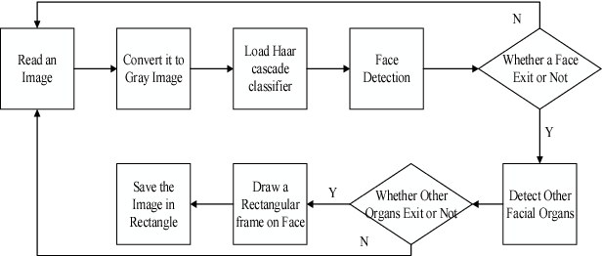

**Figure 1: Haar Algorithm**

## Internet of Things (IoT)

The internet plays a very important role in the modern era as a technology is advancing. IoT is a system of appropriate to computing devices, such as laptops, mobiles, and also be digital machines, objects, animals or people that are offered with exclusive identifiers (UIDs) and the capability is to transfer to data world wide web and over a network without the requiring human-to-human or human-to-computer communication. Internet of things (IOT) is b based on communication framework using data collection workflow and an algorithm for devotion recording.

Internet of things (IOT) is used to improve the learning, opportunities and to refine educational practices to better for student [1]. New innovations in IOT make it possible to spread its usage in every field. In the field of health, it can be used to detect medicines and illnesses of the patient. In agriculture, the IOT with multiple sensors can be used to check the temperature, soil conditions, and humidity that are important for plants. In the field of smart building, IOT can be used to monitor the home appliances and overall usage of the building.

In the future, the common use of IOT is likely to advance the worth of human life and enhance the efficiency of organization and giving an opportunity to them. The driver drowsiness in one of the problems in improving the lives of people. It has the become the major issue that the world faces regardless of the situation of a developer or developing country. The important concern in driver drowsiness is that the alert system is generate every vehicle. IOT can handle this problem through the concept of real-time- driver downiness alert system.

**IoT Stack**

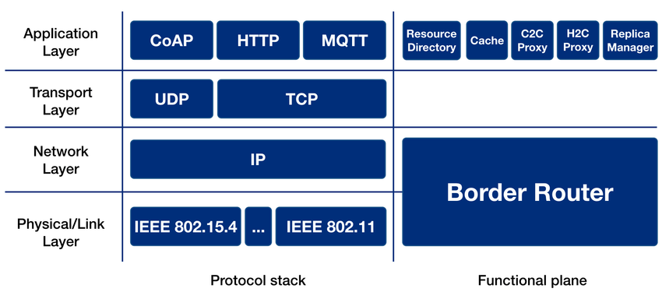

**Figure 2: IoT Stack**

IOT stack contains different layers that define standard and protocols. At the physical layer, the IEEE 802.11 protocol is used, which is designed for permitting communication between compact and low-cost power entrenched device. At the network, layer, the IP protocol is used for routing.

## Related Works:

In this technique, they used eye blinking as an input. According to the rate at which the eye blinks, drowsy condition is detected. Camera is used to capture the image of an eye, placed in front of the driver in a car. This system was implemented based on 8-15 frames per second. If the driver’s eye blinking pattern changed for more than 3-4 seconds, than driver is declared in a drowsy condition and as a result buzzer alarm and vibration will be generated. Classification of the drowsy condition is done using SVM (Support Vector Machine) classifier. It is implemented using Open CV and Raspberry pi. In Open CV, memory allocation is a big issue and it does not have its own IDE for execution. Raspberry pi does not give real time data and does not contain analog to Digital Convertor 3. Only one eye is considered for monitoring.

This technique is efficient to drivers and it had done switching between the manual and automatic driving. Whenever the driver is found in a drowsy condition, driving mode of the vehicle will be switched from manual mode to automatic mode. Driver drowsiness condition is detected based on facial expression and steering wheel data. The features extracted from both the approach are passed to the SVM classifier to classify the state of the driver. Simulated Testable, which includes driving simulator, tool to design road and script to control simulator’s behavior. Using automatic driving is not more reliable.More expensive to implement in real life. They are many small technical issues in automatic mode may be dangerous for the driver.

In this model, self-designed wrist watch is used to detect drowsy condition. Photoplethysmogram (PPG) sensor and galvanic skin response sensor is built in watch. The sensor data are sent to the mobile device for signal processing along with the accelerometer and Gyroscope, which already built in the watch. They are five features are extracted using these sensors which are moved further for drowsy detection. SVM is used to classify drowsy condition. If driver is in a fatigue condition, then graph will be generated on a mobile phone along with the vibration in watch. PPG, GSR, accelerometer and Gyroscope is used for signal processing. Phone may get misplaced while driving, so driver will be unable to see the graph. Wearing watch while driving may not be found comfortable sometimes for a long distance.

IOT is latest technology developed for communication between physical devices in a network. In this model IOT is used to process data from one end to another in case to drowsy driver. In this measure detection is done on the basis of alcohol concentration, facial expression, nature of the road and the movement of the driver vehicle. If the driver is found in a drowsy condition than the information is passed to the local traffic control. Data obtain from the entire stream will be clustered and classification will be done on the basis of this cluster. Major limitation of Internet of Things is very complex to implement. Inaccuracy in any one data may lead to poor result.

In this technology, we detect driver drowsiness can also be used to calculate driver drowsiness level. we study driving time data and driver information, improves the accuracy of face detection and predict of drowsiness. They are many participants, drove a car simulate for 110 min under drowsiness condition. We measured the driver physiological, condition and its behavioral such as heart rate, breathing rate, head and eye, movements of eye blink duration frequency and recorded driving behavior and its drowsy condition. sensorimotor indicators, Physiological features are also frequently used to assess drowsiness, electroencephalogram, electrocardiogram and electro-dermal are used to recording signals. It is difficult to implement. Inaccuracy signals may send to poor result due to some kind of technology failure.

In this proposed model, we show the need of a dependable drowsiness detection the system alert the driver, before accident happens. We control driver drowsiness using the following measure. They are different types of measure Vehicle-based measure, behavioral measure and physiological measure. We determine by designing a drowsiness detection system, that combine physiological measure with behavioral measure, would accurately determine the driver drowsiness level. A number of road accident can be avoided if an alert is sent to a driver, that is drowsy stage. Vehicle-based measure moment of the steering wheel movement (SWM), behavioral measure including yawning, eye closure, eye blinking, physiological measure physiological signals (ECG) electrocardiogram, (EMG)electromyogram, (EOG) electrooculogram used to detected driver drowsiness. Very complex and expensive they are many sensors are used. Inaccuracy the steering wheel the acceleration pedal, the signals sent by the sensors to analyzed to determine the level of drowsiness, the signal sent the wrong information the reason about speed.

Driver fatigue detection system is called (FDS). The driver fatigue detection system (FDS) is basically used to monitor the driver and the attentiveness of the driver and stop them from falling asleep. Fatigue detection system (FDS), software is modified to be run in smartphone laptops, which is fixed in a car and use advantages of smartphone like camera. This system will solve this problem of driver drowsiness by using a mobile phone camera the phone will be put on a stand in the car to make the driver feels comfortable. The model has based on hardware and software components such as mobile phone camera and android software development kit (SDK). Components are integrating together, to record real video for the driver behavior, then processing it for real-time eye tracking. Techniques are used to detect driver fatigue: physiological measurements, measure feature such as brain waves (EEG), eye moments (EOG) and the electrocardiogram (ECG) signals of driver.

## IoT Protocols:

There are various protocols of IOT but some of them are given below:

### Wi-Fi Protocols (IEEE 802.11)

IEEE 802.11 is part of the IEEE 802 set of Local-Area-Network (LAN) protocols, for implementing Wireless-Local-Area-Network (WALN). It is an IOT data link layer protocol. It is most used wireless computer networking standard, used in home and office network. It also permits the exchange of information between laptops and smartphones and to give access to the internet without connection wire. This protocol is used in our project when sensors have to send message to the server. This Wi-Fi protocol helps in sending message or data to the IOT server.

### MQTT Protocol

Message queuing telemetry transport (MQTT) is one of the most commonly used in internet of things (IOT). Its works on application layer protocol for sending a command and control the output. MQTT is a small size low power uses, minimized data packets and ease of implementation make the protocol idea of the machine to machine or internet of things (IOT) world. It based on messaging technique because we have to need fast messenger, WhatsApp message deliver, MQTT is basically minimized data packets, that’s why low network use or low power use. Its real time is perfect for IOT application.

### Bluetooth Protocol (IEEE 802.15.1)

Bluetooth is a standardized protocol for sending and receiving data via a 2.4GHz wireless link. It's a secure protocol, and it's perfect for short-range, low-power, low-cost, wireless transmissions between electronic devices.

## Machine learning (ML)

Machine Learning is a field of study that enables computers to think like a human. In ML, systems are trained to analyze data for making a decision according to the situation. Although, ML is a field in computer science, that have been classified into several categories like Vector Quantization [15]. Typically, ML is a branch of Artificial Intelligence which allows the system to analyze data and take decisions or make predictions about the data without any human involvement. There are many algorithms as well as a statistical model which make the system to perform any task or making any prediction effectively. Two main learning algorithms are mention below.

### Supervised Learning

Supervised ML is the search for algorithms that takes external instances to produce a general hypothesis. It can be useful for making future predictions. In supervised ML, true or false labels of the input dataset are available. The algorithms are trained on a given dataset. In the training process, the algorithms make predictions for the test class. They are many supervised learning classifiers.

### Naive Bayes

Naive Bayes is a supervised machine learning classification algorithm. Naive Bayes uses probability to determine the class of data. It is used Bayes theorem and probability of an object changed when a new object comes. We calculate the probability of each category and then the highest probability is the output and the object lie in that category.

### Linear regression

Linear regression is a classification algorithm used to predict unknown value from known values. It is also a supervised learning algorithm. Its subcategory is called simple logistic which is similar to linear regression. Simple logistics regression uses an equation. Input values X are combined with W weights to predict a Y output. The difference between in this and linear regression is that the output values of these are model as a binary number rather than numeric values.

### Unsupervised Learning

In unsupervised learning, there are no labels for the dataset. This may sort the information based on similarities and differences even though there are no categories defined. It can perform more complex tasks than supervised learning. Unsupervised learning is used to know about the data by underlying the distribution or structure of the data. In unsupervised learning, there is no teacher and no correct labels. The algorithm is left to their own to present the structure or distribution of data. There are only classifiers of unsupervised learning.

### K Nearest Neighbor

A powerful classification algorithm used in pattern recognition. K nearest neighbors stores all available cases and classifies new cases based on similarity measures. It is one of the top data mining algorithms used now a days. It is a non-parametric lazy learning algorithm and also called an Instance-based Learning method. So, these are some common and vital ML algorithms help us to ensure accuracy of our module.

## Relationship Between IOT and ML:

In recent year, major improvements in developing technologies and the internet have made interaction among devices much easier than before. IOT is gradually invading in each and every phase of our lives. IOT provides a network environment where all the software, sensor and electronics containing devices allow to connect to the internet and interact with each other for exchanging data. But all these devices are still not flawless even though they are linked to the internet. They require manual action to perform their tasks as they are not intelligent like human. Systems should capable of accessing data from the internet.

## Association of IOT with Cloud:

IoT Cloud is a platform from Salesforce.com that is designed to store and process Internet of Things (IoT) data. The platform is built to take in the massive volumes of data generated by devices, sensors, websites, applications, customers and partners and initiate actions for real-time responses. In our project, we send our data to cloud to manage the brief history of a particular entity through gateway. Additionally, we should perform some ML decision on cloud.

# Proposed Methodology

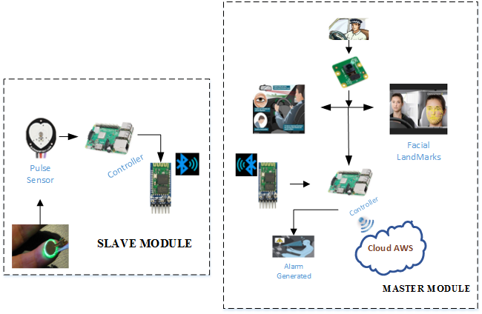

**Figure 3: Methodology of proposed system**

Our proposed methodology is based on both visual and non-visual parameters and both factors interact with each other using Master-Slave phenomenon. Master module starts by detecting facial landmarks of the driver and then focus on eyes to calculate EAR (Eye Aspect Ratio) values on real time. If EAR value>0,3, then the driver is said to be in conscious state. If not, then driver is in unconscious state. On the other hand, non-visual or slave module takes the pulse rate of driver on real time. Thus, if the pulse rate is normal(60bpm-100bpm) then the driver is said to be active or driving intentionally. Otherwise, driver feel sleepy. Hence, from both of these calculations’ controller made a decision to generate alarm or not. Furthermore, Master module also send brief history of drowsiness against particular entity on cloud to maintain record.

## Data Flow Diagram

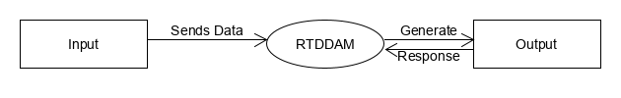

**Figure 3: DFD Level 0**

DFD 0 defines the flow of RTDDAM in a very abstract form. As the level 0 above describes the flow that PiCam/Pulse sensors sends input to the system, after processing it gives an output in the form of alert generation.

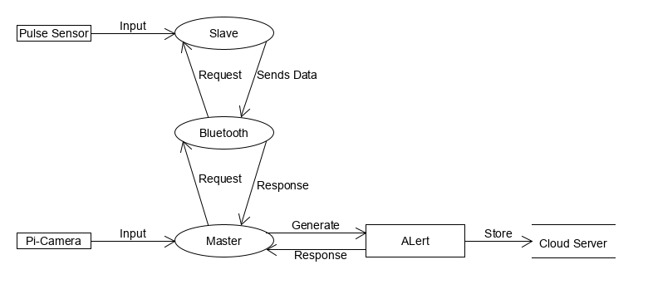

**Figure 4:DFD Level 1**

DFD level 1 show the system more briefly. Figure 4 shows that pi-camera and pulse sensor send data to controller that generate alarm on the basis of that data and then send it to IoT cloud server through gateway to maintain the record of driver’s drowsiness.

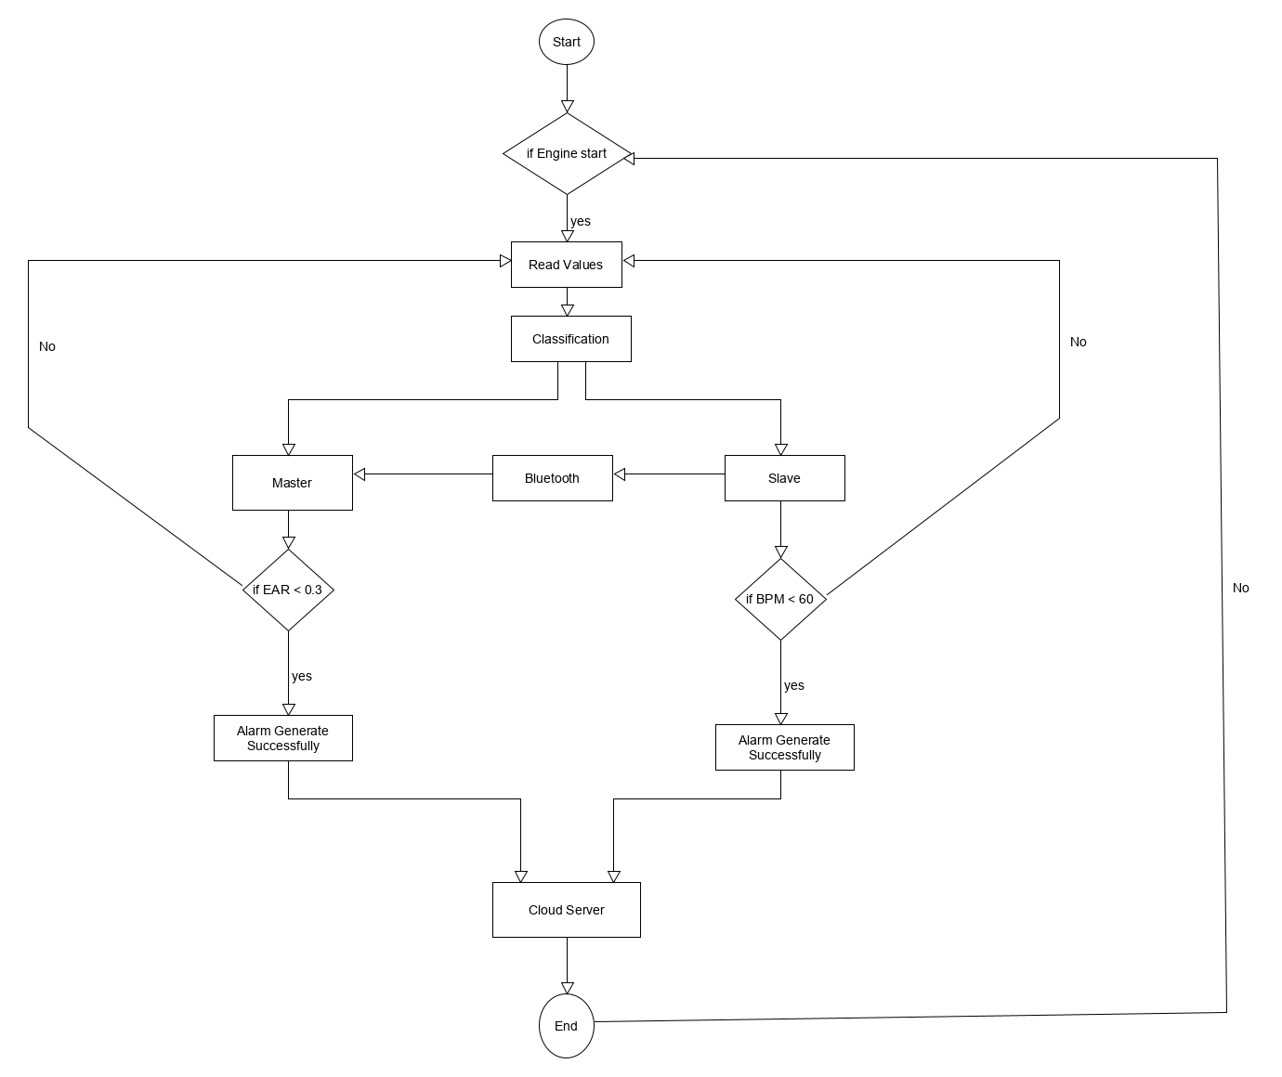

**Figure 5: Flow of the system**

The workflow of RTDDAM shows that with the help of Pi-Cam and Pulse Sensor system detects drowsiness of the driver. The detection is stored/compared in the form of values. If the values violate or not according to the conditions which were set already then, the driver is said to be drowsy and our system generate an alarm to wake up the driver to stay alert. Secondly, if the values do not violate or opposite to the pre-defined values then the system is evaluating the driver continuously. Furthermore, system also associate with IoT cloud server to maintain the brief history of driver’s drowsiness.

# Design and Implementation

## List of components

### Raspberry Pi(3B+)

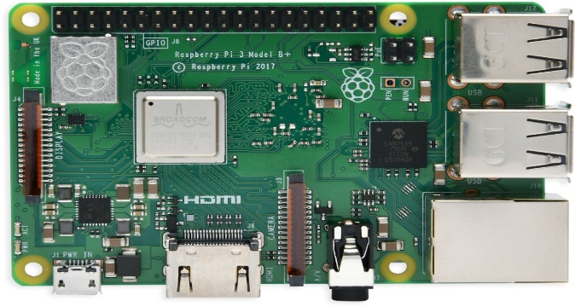

**Figure 6: Raspberry pie 3B+**

The simplest use for a Raspberry Pi is as a desktop computer. Along with the Pi itself, the microSD card, and power supply, you'll need a HDMI cable and a suitable display. As with a traditional computer, you'll also need a USB keyboard and mouse. It consists of 1.4 GHz CPU which helped boost its performance from 1.2GHz to 1.4 GHz. It contains USB Ethernet controller offers gigabit connectivity at a theoretical maximum throughput of 300Mb/s, due to its use of a single USB channel. Finally, a clever power management integrated circuit (PMIC) replaces discrete components and provides smoother power. Although, Raspberry Pi 3B+ has Wi-Fi and Bluetooth built in. Moreover, it also has pi camera connectivity to capture/take videos.

### Pi Camera

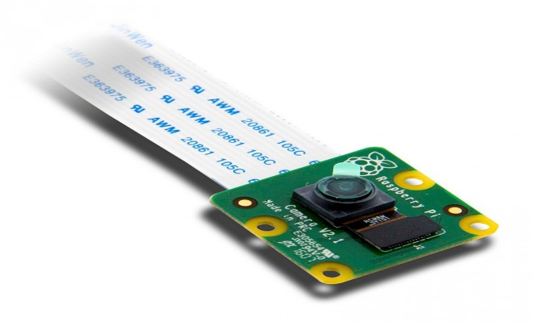

**Figure 7: Pi-Cam**

The Pi Camera is used to capture pictures or taking videos as well. Although, it helps a lot to work on image processing and it comes with many pixel sizes like 2mp,5mp,8mp etc.

### Pulse Sensor

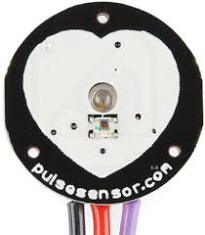

**Figure 8: Pulse Sensor**

Pulse Sensor is a well-designed plug-and-play heart-rate sensor for Arduino. It can be used by students, artists, athletes, makers, and game & mobile developers who want to easily incorporate live heart- rate data into their projects. It also includes an open-source monitoring app that graphs your pulse in real time.

# Evaluation

## Experimentation

In this work, we developed a smart real time driver detection module which is being tested on 15 users till now according to the age range. We also considered the patients affected from different diseases in order to check the response of RTDDAM according to the pulse rate variation. We also visited different clinics in order to test our system on different patients. We are also making our own dataset according to the format shown in Table 1, to make effective recommendation through cloud server. Our testing module, still under process in order to check and evaluate our proposed system in multiple real time environments which takes time.

Table 1:Data-set Format

|  |  |  |  |  |  |
| --- | --- | --- | --- | --- | --- |
| User ID | Age | Gender | Bpm | Disease if any | System Response  (Sec) |

### Experimental Setup

We are using two computing devices i.e. Raspberry Pie 3B+ and Arduino UNO which are interlinked through Bluetooth Protocol IEEE 802.11.1. Raspberry Pie 3B+ is a mini processor which has 1 GB RAM and 32 GB SD Card as a memory. It has Cortex A7 processor through which we are able to manipulate image processing applications. On the other hand, Arduino UNO is used for low computing applications generally used for triggering purposed on the basis of external sensors inputs. We used two external inputs one for Pie i.e. User Image Frame and the other is user pulse rate which is calculated through Arduino. Through Wi-Fi protocol IEEE 802.11 a/g/n/b output drowsiness status also been transfer to AWS IoT cloud server which is used for recommender system for the Admin as shown in

### Experiments Design/Details

We developed two modules such as master and slave, in order to detect drowsiness state effectively. These two modules are communicate with the help of Bluetooth communication phenomenon. Master module is been placed on the line of sight of the driver seat and the slave module is wear on the wrist of the driver in order to check the pulse rate in the form of Bpm. Slave module send the BPM value to the master module and the master module check both EAR and BPM parameters with respect to the pre-defined threshold limit which ultimately direct to the AWS cloud server for recommendation.

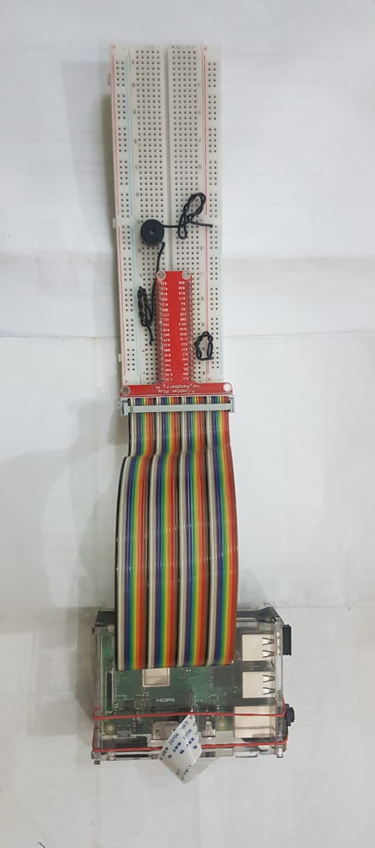

**Figure 9: Master Module**

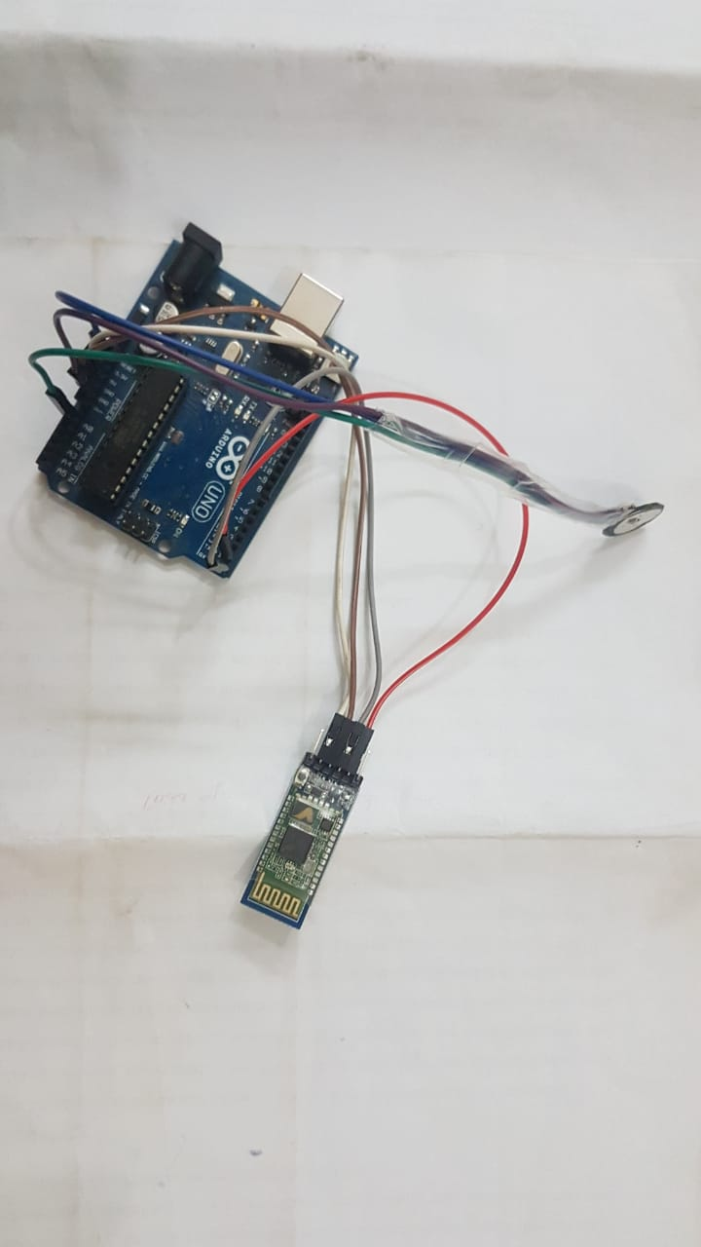

**Figure 10: Slave Module**

## Algorithm-1

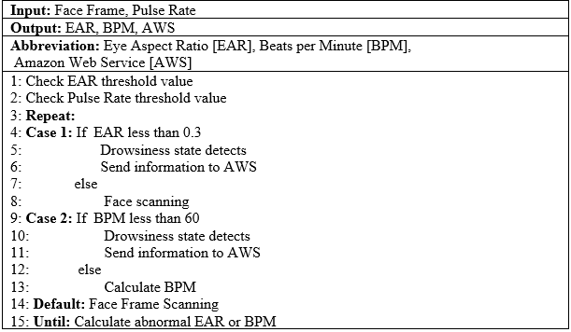

In Algorithm 1, we describe the driver drowsiness detection phenomenon with the help of multiple input features such as face frame and pulse rate. In order to detect the drowsiness state, we need to calculate two parameters i.e. Ear to Eye ratio (EAR) and Beat per Minute (BPM). After that we compare the EAR value with reference to the particular pre-set threshold i.e. 0.3 in our case. If the EAR is less than 0.3, it represents the drowsiness state condition on which buzzer activated alongside values also send to the AWS cloud server. In parallel to that, BPM is also calculated of the particular driver only if the pulse rate is less than 60 and the system response in the similar fashion as for previous feature. Finally, this system continues until the car engine is active.

## Results and Discussion

We are evaluated our proposed system (RTDDAM) on the basis of two parameters such as: Response Time and Percentage Accuracy

### Performance Metrics

1. Percentage Accuracy (PA):

Percentage Accuracy evaluation parameter is the difference between actual response time of the system to the desired output response of RTDDAM and ultimately taking difference from the 100 which is referred to 100 %. It is numerically represented as shown in eq.1

PA= $100-(x-x0)$ Eq. 1

Here x = output response in terms of delay and x0 = nominal system delay on which RTDDAM achieves 100% accurate

1. Response time w.r.t Age (RTA):

It is calculated experimentally by taking average values of pulse rate in the form of Bpm and EAR value on the multiple patients and users Age with respect to system response time in sec.

1. Response time w.r.t # of Frames (RTF):

It is calculated by changing the value of total number of video frames in order to detect the particular face.

## Response time w.r.t Age (RTA):

RTA represents the variation in RTDDAM response time with respect to human age difference according to the BPM and EAR values in shown in Fig 1:

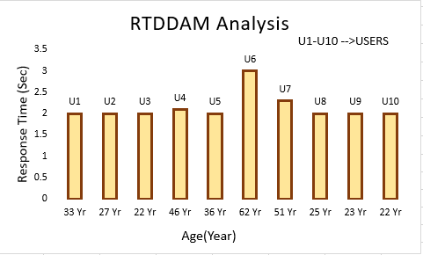

**Figure 11: RTDDAM Analysis**

In Fig. 8, it is clearly shown that the response time of RTDDAM is almost constant i.e. 2s when the age limit is between 18 to 36 years. As our proposed system is time critical as well as event triggers, so 2s is the close to ideal time in order to alert the driver in case of any mishap. Moreover, in the range of 40 to 55 years, a slight increase in the RTDDAM delay which is nominal one i.e. 2.1 to 2.3s due to the medical as well physical variations in the human body. After that above 60 years of age RTDDAM take more time to calculate EAR which is around 3sec, but according to the Driving SOP’s above 60 age of a driver is not being eligible to drive a vehicle due to the natural variations in the human body like Eye sight and Pulse Rate etc.

## Response Time w.r.t no. of Frames (RTF):

Similar to RTA, RTF is also representing the response time of a system, but according to the total numbers of input video frames as represented in fig. 2.

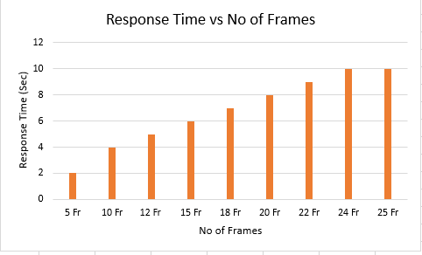

**Figure 12: Response Time in terms of # of input frames**

As shown in fig. 2, the frame no’s. also effects the RTDDAM response. As, the number of frames become increases, the proposed system delay also increases due to more computations required in order to compute evaluation parameters. In RTDDAM, we set the frame rate =5 because it is the minimum delay, we need in order to detect the drowsiness state.

## Percentage Accuracy (PA):

PA is another evaluation metric in order to calculate the performance of the proposed system as shown in fig. 3.

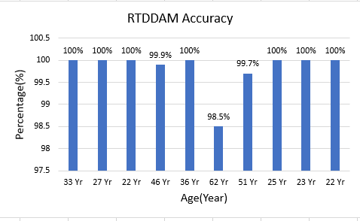

**Figure 13: RTDDAM System Analysis**

According to figure 3, it depicts that our proposed system response perfectively when the age limit is between 18 to 36 years i.e. 100% and a slight variation, we see in the age range of above 40 and above 50 which is around 0.1 to 0.3 %. A major difference we analyze in the RTDDAM response i.e. 98.5% when the age limit crosses 60 year of age due to the same factors as discussed in section 6.3.

# Conclusion and Future work

The proposed system (RTDDAM) is develop to detect the drowsiness state of a drive-in real-time environment. Although, there are enormous efforts has been done by the researchers in order to developed an effective and flexible mechanism to detect the drowsiness state, but there are still large number of wide gaps available to improve the existing methodologies. By analyzing the loop holes in the existing approaches, we proposed IoT-ML based real time driver drowsiness alert mechanism which is more productive, efficient and efficient after viewing the testing results of the proposed system (RTDDAM).

In future, we will plan to enhance the proposed gadget by introducing the GPS phenomenon in the smart city environment. Further, we will plan to install the proposed phenomenon in the local and international transport service to secure human lives due to road accidents as much as possible.

# Refferences

1. “Drowsy Driving,” National Highway Traffic Safety Administration (NHTSA), 01-Feb-2018. [Online]. Available: https://www.nhtsa.gov/risky-driving/drowsy-driving. [Accessed: 11Apr-2018].
2. A. Industries, “Raspberry Pi 3 - Model B - ARMv8 with 1G RAM,” adafruit industries blog RSS. [Online]. Available: https://www.adafruit.com/product/3055. [Accessed: 06-Mar-2018].
3. “Camera Module,” Camera Module - Raspberry Pi Documentation. [Online]. Available: https://www.raspberrypi.org/documentation/hardware/camera/. [Accessed: 28-Nov-2017].
4. Z. Li, L. Chen, J. Peng, and Y. Wu, "Automatic detection of driver fatigue using driving operation information for transportation safety," Sensors, vol. 17, no. 6, p. 1212, 2017.
5. “Drowsy Driving,” National Highway Traffic Safety Administration (NHTSA), 01- Feb-2018. [Online]. Available: https://www.nhtsa.gov/risky-driving/drowsy-driving. [Accessed: 11Apr-2018].
6. A. Industries, “Raspberry Pi 3 - Model B - ARMv8 with 1G RAM,” adafruit industries blog RSS. [Online]. Available: https://www.adafruit.com/product/3055. [Accessed: 06-Mar-2018].
7. “Camera Module,” Camera Module - Raspberry Pi Documentation. [Online]. Available: https://www.raspberrypi.org/documentation/hardware/camera/. [Accessed: 28-Nov-2017].
8. P. M. Forsman, B. J. Vila, R. A. Short, C. G. Mott, and H. P. Van Dongen, "Efficient driver drowsiness detection at moderate levels of drowsiness," Accident Analysis & Prevention, vol. 50, pp. 341-350, 2018.
9. Z. Li, L. Chen, J. Peng, and Y. Wu, "Automatic detection of driver fatigue using driving operation information for transportation safety," Sensors, vol. 17, no. 6, p. 1212, 2017.
10. **“**Drowsy Driving: Asleep at the Wheel,” Centers for Disease Control and Prevention, 07-Nov-2017. [Online]. Available: https://www.cdc.gov/features/dsdrowsydriving/index.html. [Accessed: 11-Apr-2018].